**EXPERIMENT 16**

Create a Simple Web Application using Java or Python and host it in any Public Cloud

Service Provider (Azure/GCP/AWS) to demonstrate Platform as a Service (PaaS) Click on app services

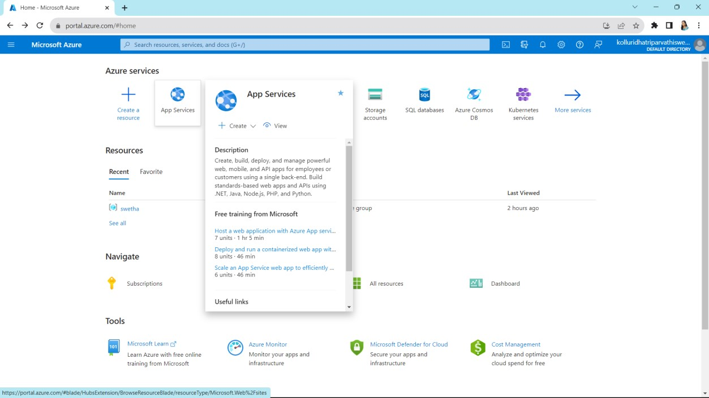

Click on create

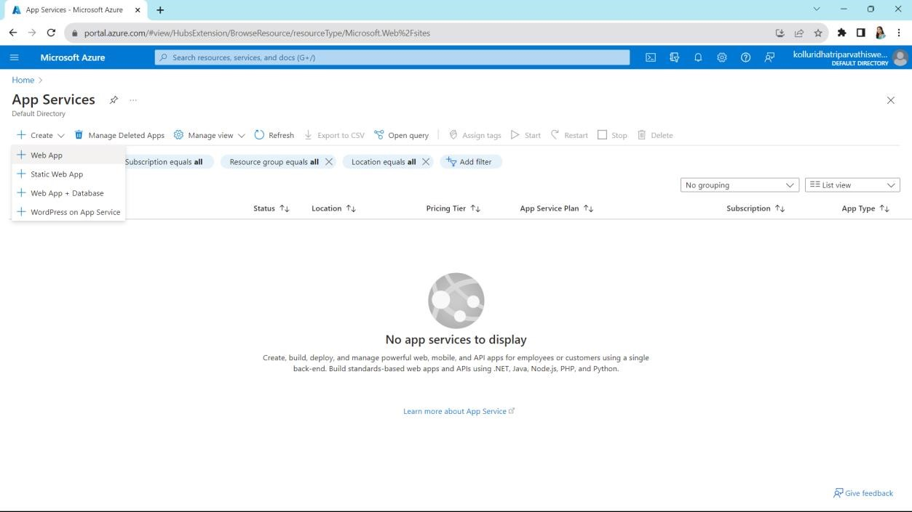

Select any resource group and choose static web app

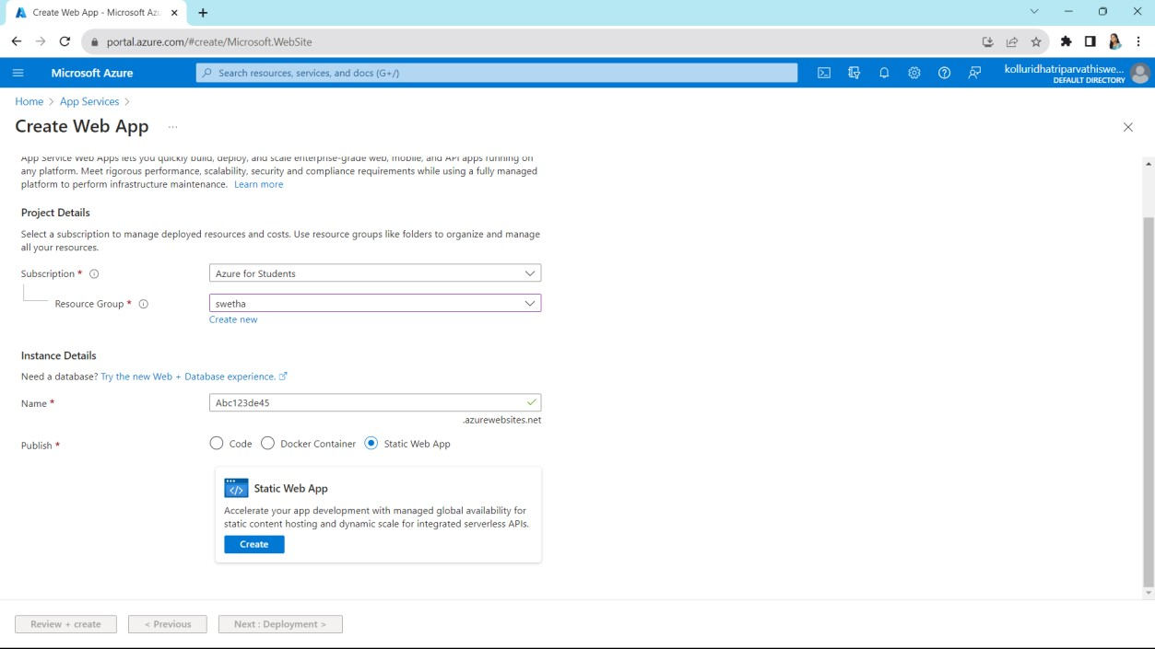

Fill up required details and click on next

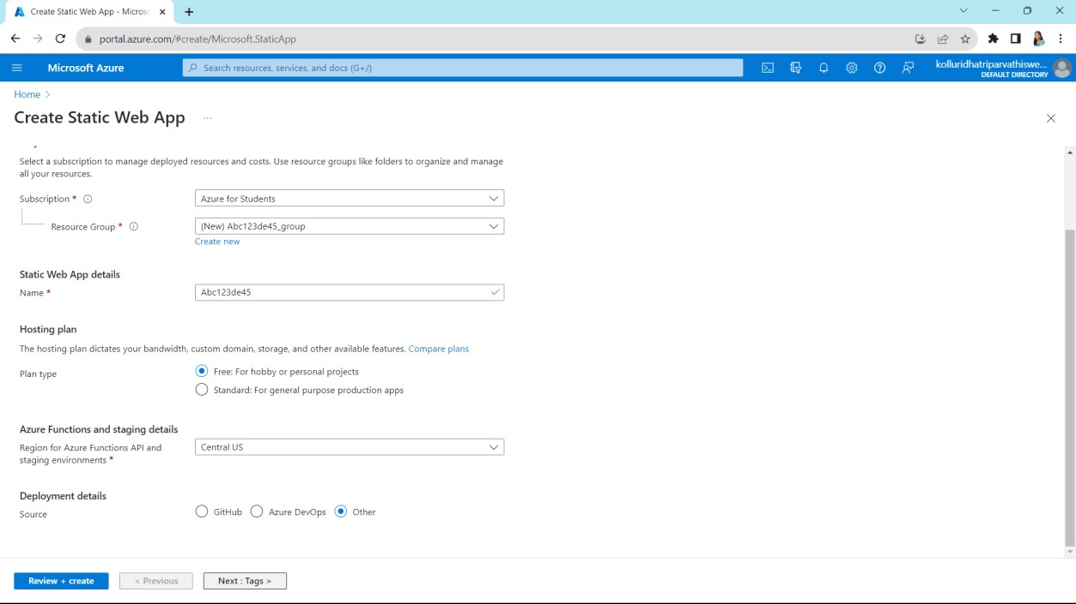

Give some names and values

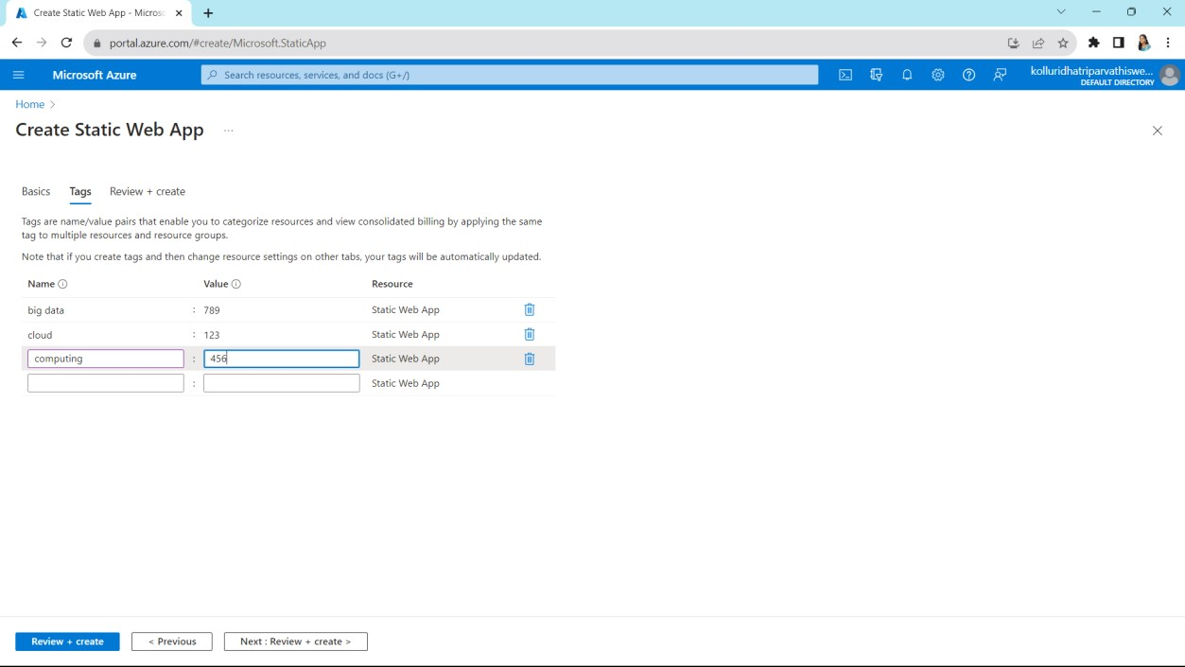

It shows our summary

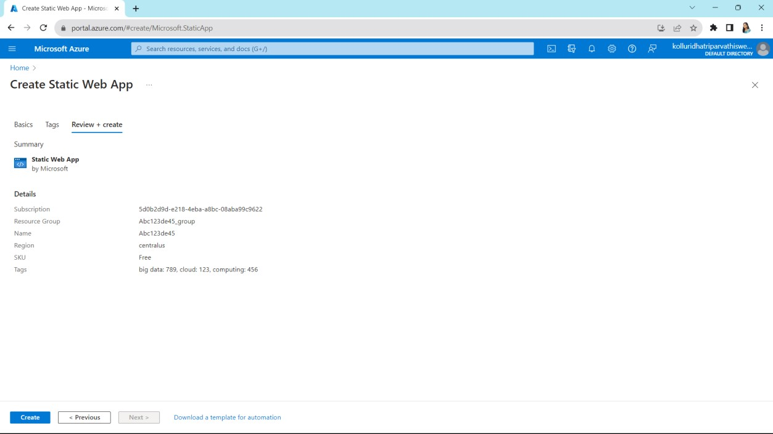

Click on go to resources

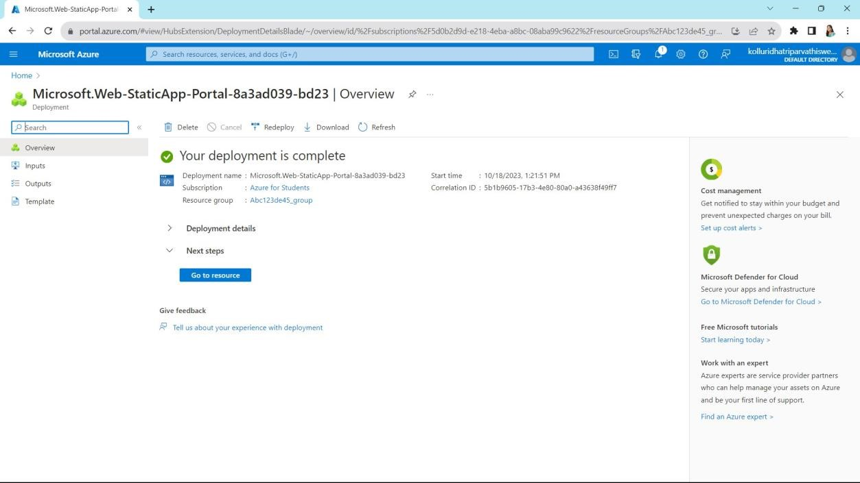

Copy the URL which is right side top

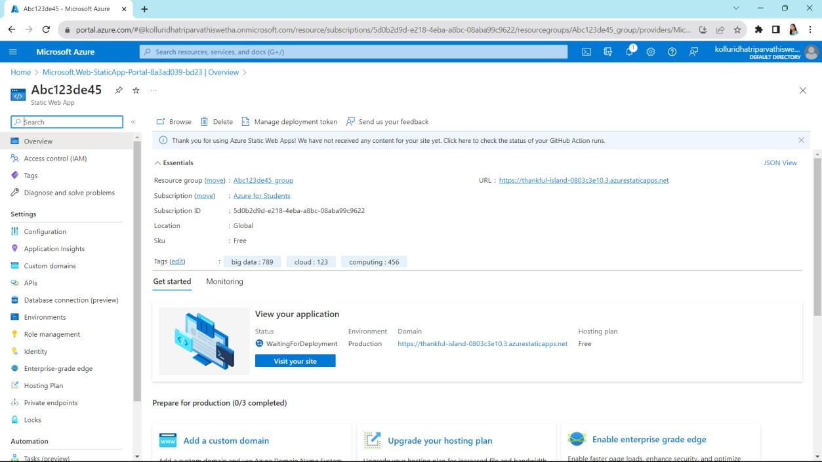

Paste the URL on search bar and then click enter it will shows like this

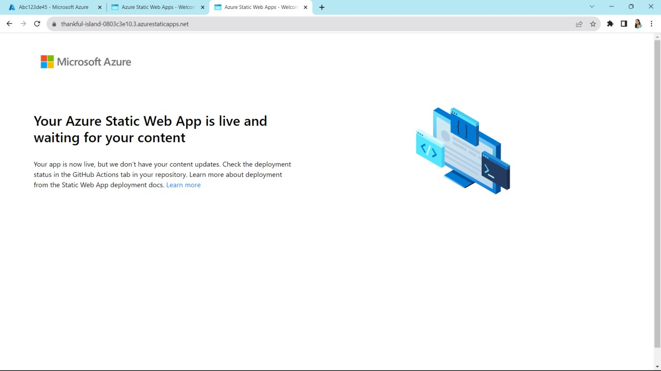

Finally Created a Simple Web Application